ELECTRONIC SUPPORTING INFORMATION (ESI)
Factors Influencing the performance of agricultural extension services on women farmer groups in Luwu Regency, Indonesia

Besse Amisnawati, Syafruddin*
Department of Agricultural Extension, Faculty of Computer, Engineering, Agriculture and Marine Sciences, Universitas Muhammadiyah Palopo, South Sulawesi, Indonesia

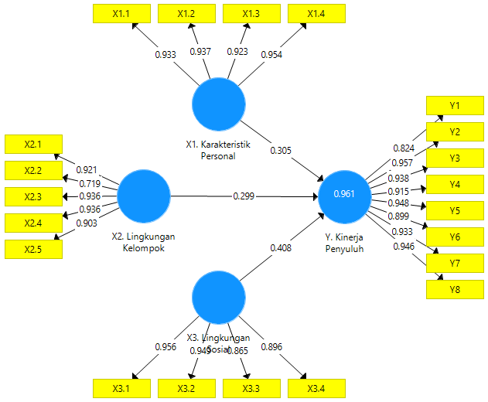

Gambar S1. Model SEM (Output SmartPLS)

Tabel S1. Nilai Average Variance Extracted (AVE) pada variable model SEM
Variabel | Average Variance Extracted (AVE)
X1. Karakteristik Personal | 0.877
X2. Lingkungan Kelompok | 0.787
X3. Lingkungan Sosial | 0.841
Y. Kinerja Penyuluh | 0.848

Tabel. S2. Nilai Composite Reliability dan Cronbach Alpha pada tiap variabel

Variabel | Cronbach's Alpha | Composite Reliability
X1. Karakteristik Personal | 0.954 | 0.966
X2. Lingkungan Kelompok | 0.930 | 0.948
X3. Lingkungan Sosial | 0.936 | 0.955
Y. Kinerja Penyuluh | 0.974 | 0.978

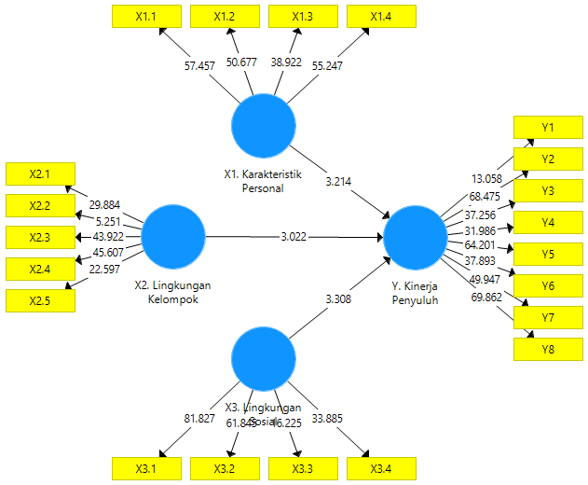

Gambar S2. Pengaruh antar variabel

Tabel S3. Pengaruh antar variabel

Pengaruh terhadap variabel Y | T Hitung | T Tabel | P Values | Cut off Value
X1. Karakteristik Personal -> Y. Kinerja Penyuluh | 3.214 | 1.697 | 0.001 | 0.05
X2. Lingkungan Kelompok -> Y. Kinerja Penyuluh | 3.022 | 1.697 | 0.003 | 0.05
X3. Lingkungan Sosial -> Y. Kinerja Penyuluh | 3.308 | 1.697 | 0.001 | 0.05

